DOCUMENTATION
ForYourEars

Problem Statement:
You are supposed to work on the following:
- Logical Architecture
- Deploy the app in scalable architecture
- Use Nginx as Frontend & App Engine as backend

The project is divided into two parts:
1. LAMP Stack Deployment
2. Microservice Deployment

LAMP Stack Deployment
Tools used in LAMP Stack Deployment:
1. Git
2. Azure Devops
3. Ansible
4. Packer
5. Terraform
6. GCP Cloud
- Compute Engine
- Image
- VPC, Subnet
- Instance Group
- IAM
- App Engine
- Cloud Firewall
- Cloud Load Balancer

Deployment-
- Write code in ansible and packer to deploy golden image in gcp(image)

Reference
Ansible Playbook -
https://github.com/Priyanka-Bisht/4yourearsProject-LAMP-Stack/blob/terraform/AppEngine-Project/playbook.yml

Packer Template -
https://github.com/Priyanka-Bisht/4yourearsProject-LAMP-Stack/blob/terraform/AppEngine-Project/packer-template.json

Azure Pipeline -
https://github.com/Priyanka-Bisht/4yourearsProject-LAMP-Stack/blob/terraform/AppEngine-Project/azure-pipelines.yml

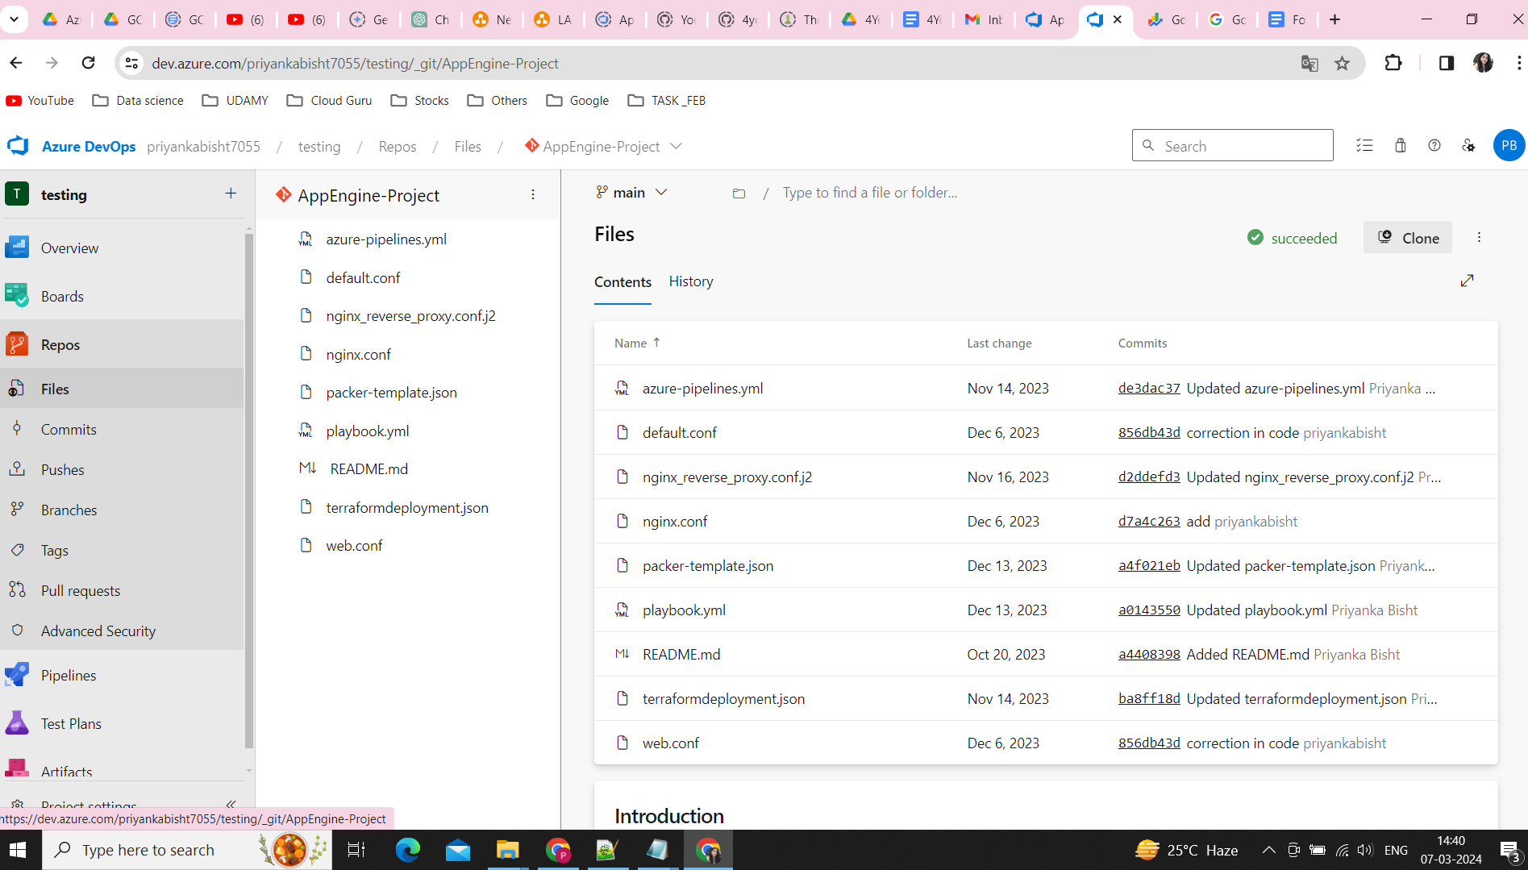

We have used pipeline variable in the library section to centralized management, reusability and for Parameterization.
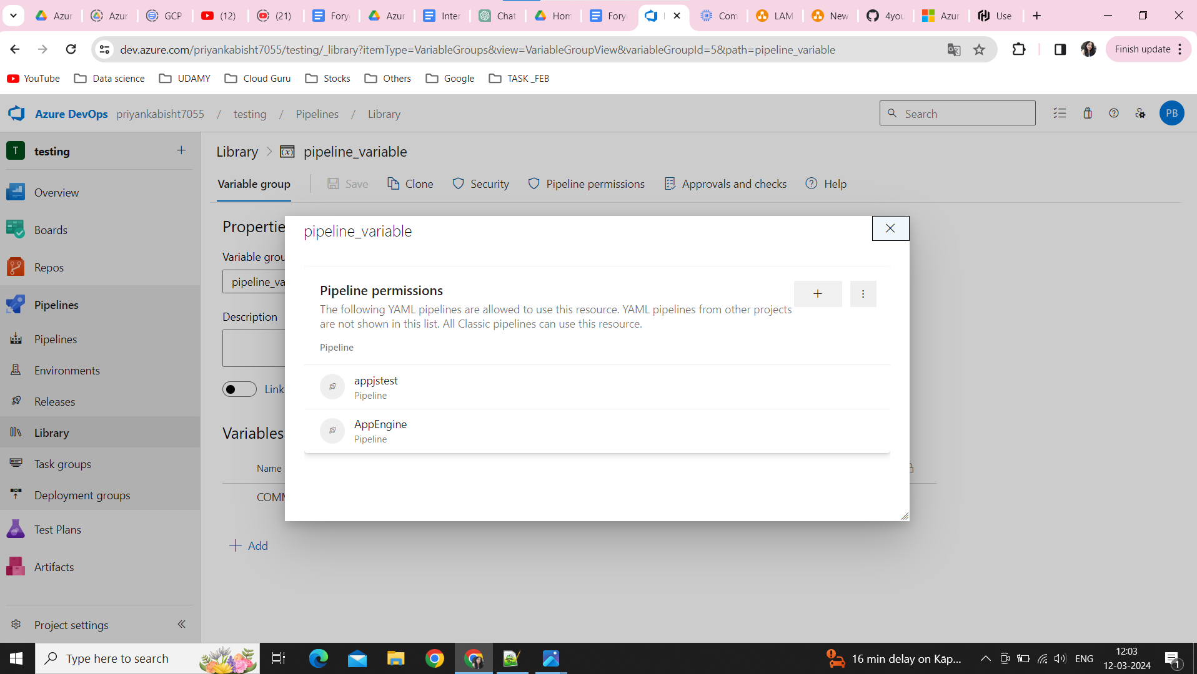

- Write code to build an azure pipeline and set variable {GOOGLE_APPLICATION_CREDENTIALS} with the value of service account json key.
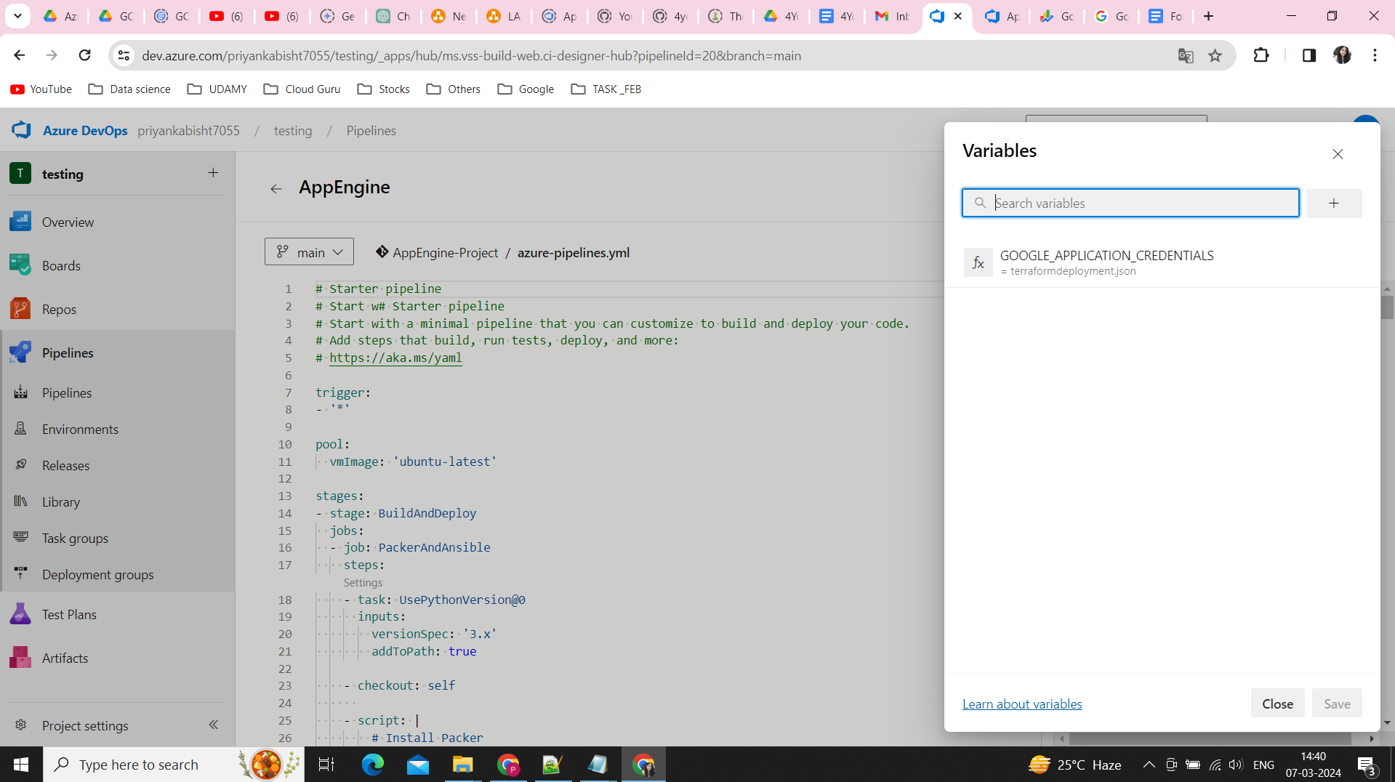

- I have used Microsoft-hosted agents to deploy the application.
Deploy the newly built image to google cloud images.
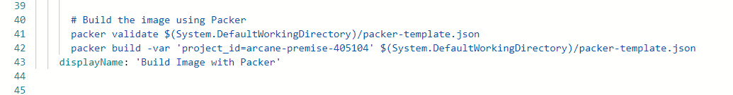

Now, the image is successfully built, we need to move to the next step.

We will use Terraform to deploy infrastructure in google cloud.
Use Terraform Module for Reusable Components, Standardizing Infrastructure and Scalability and Consistency.

We will use below modules:
VPC - https://github.com/Priyanka-Bisht/4yourearsProject-LAMP-Stack/tree/terraform/Terraform-backend-Project/Terraform/modules/VPC

Firewall - https://github.com/Priyanka-Bisht/4yourearsProject-LAMP-Stack/tree/terraform/Terraform-backend-Project/Terraform/modules/Firewall

Compute - https://github.com/Priyanka-Bisht/4yourearsProject-LAMP-Stack/tree/terraform/Terraform-backend-Project/Terraform/modules/Compute

Load Balancer - https://github.com/Priyanka-Bisht/4yourearsProject-LAMP-Stack/tree/terraform/Terraform-backend-Project/Terraform/modules/Loadbalancer

App Engine - https://github.com/Priyanka-Bisht/4yourearsProject-LAMP-Stack/tree/terraform/Terraform-backend-Project/Terraform/modules/AppEngine

IAM - https://github.com/Priyanka-Bisht/4yourearsProject-LAMP-Stack/tree/terraform/Terraform-backend-Project/Terraform/modules/IAM

Create service connection to connect azure devops to terraform.
Go to -> Project Setting - Service Connection - new service connection - Terraform - fill the details
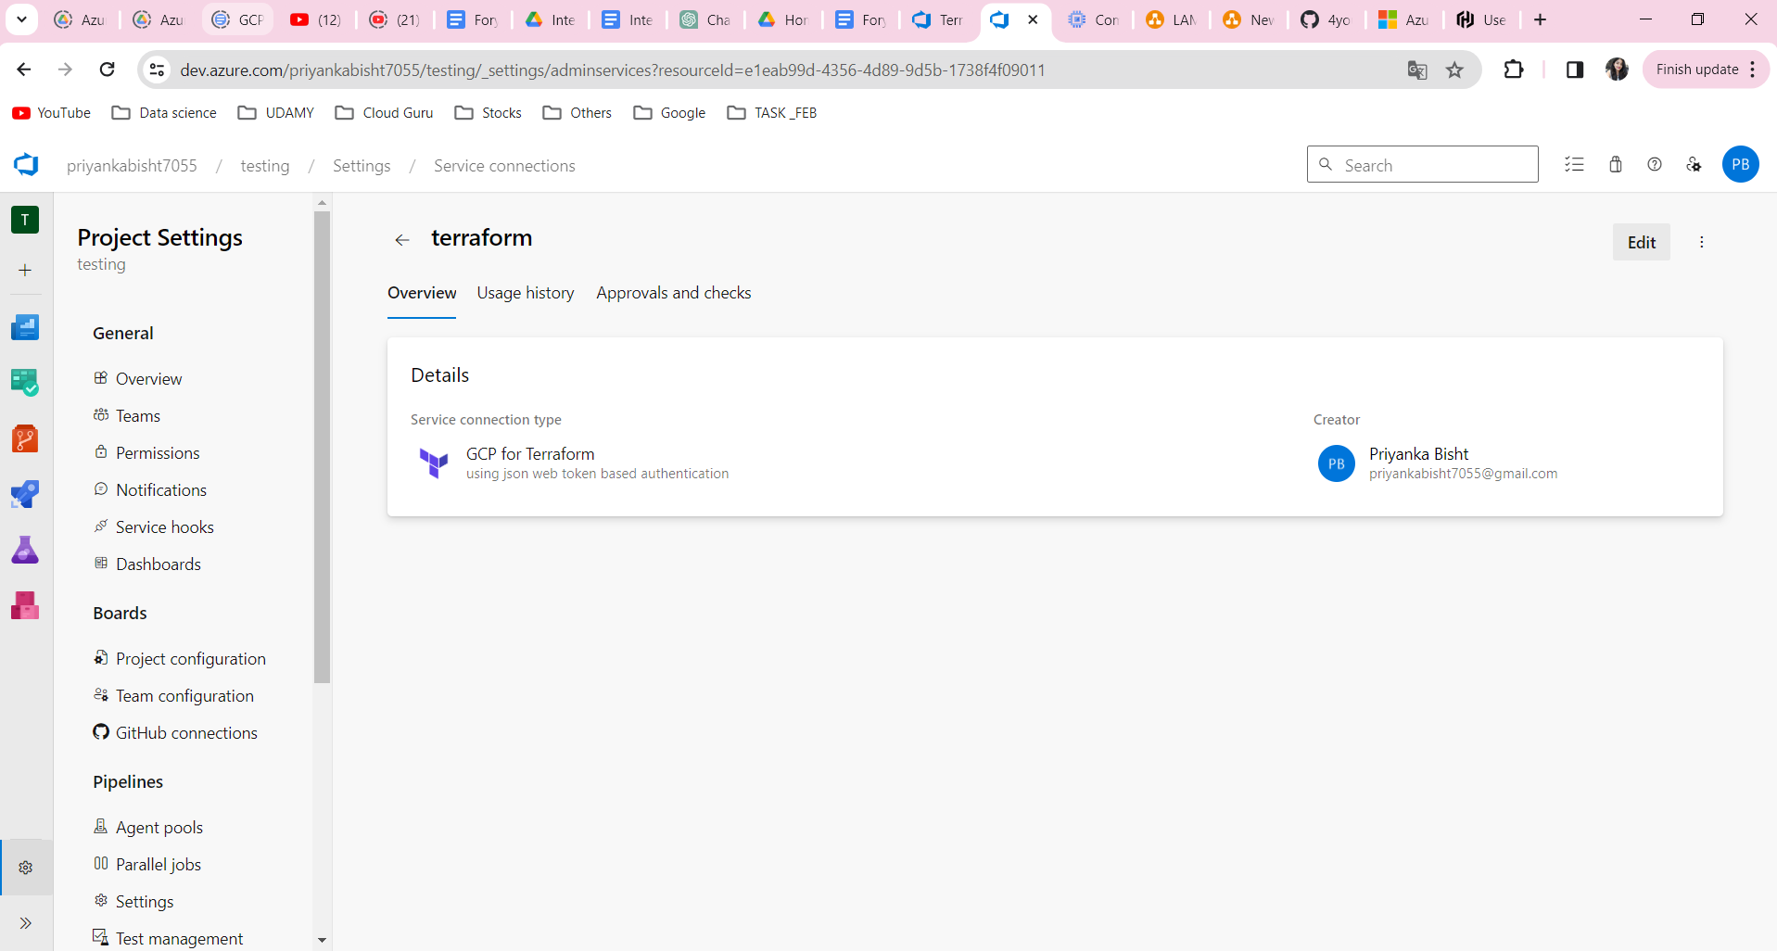
Create Repo in azure devops push the terraform code.
Create Build and publish artifacts.
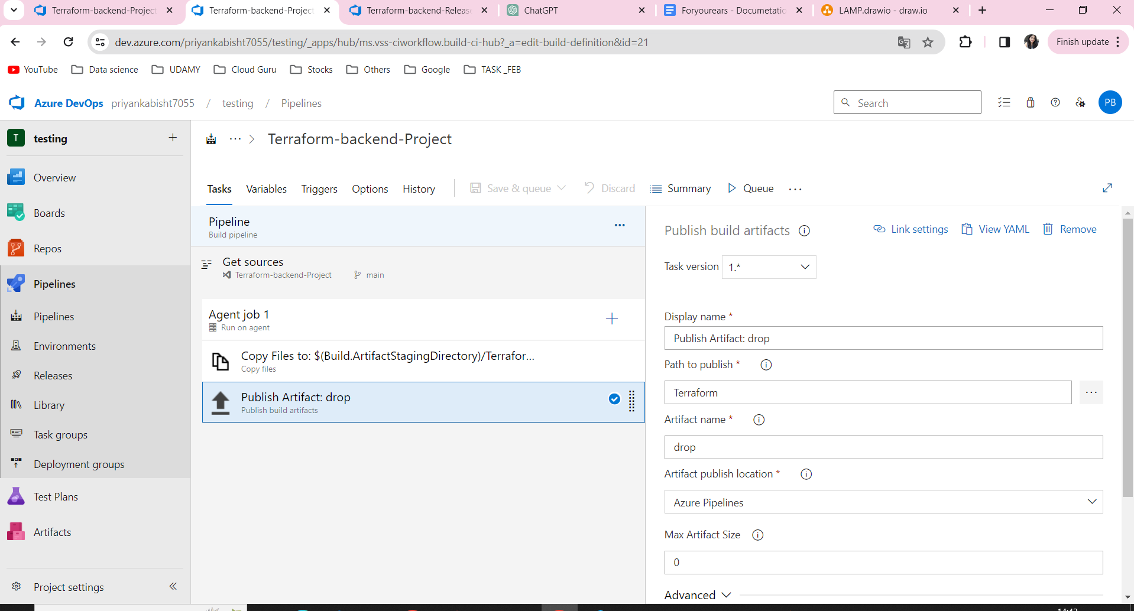

After the build is successfully created, create a release pipeline.
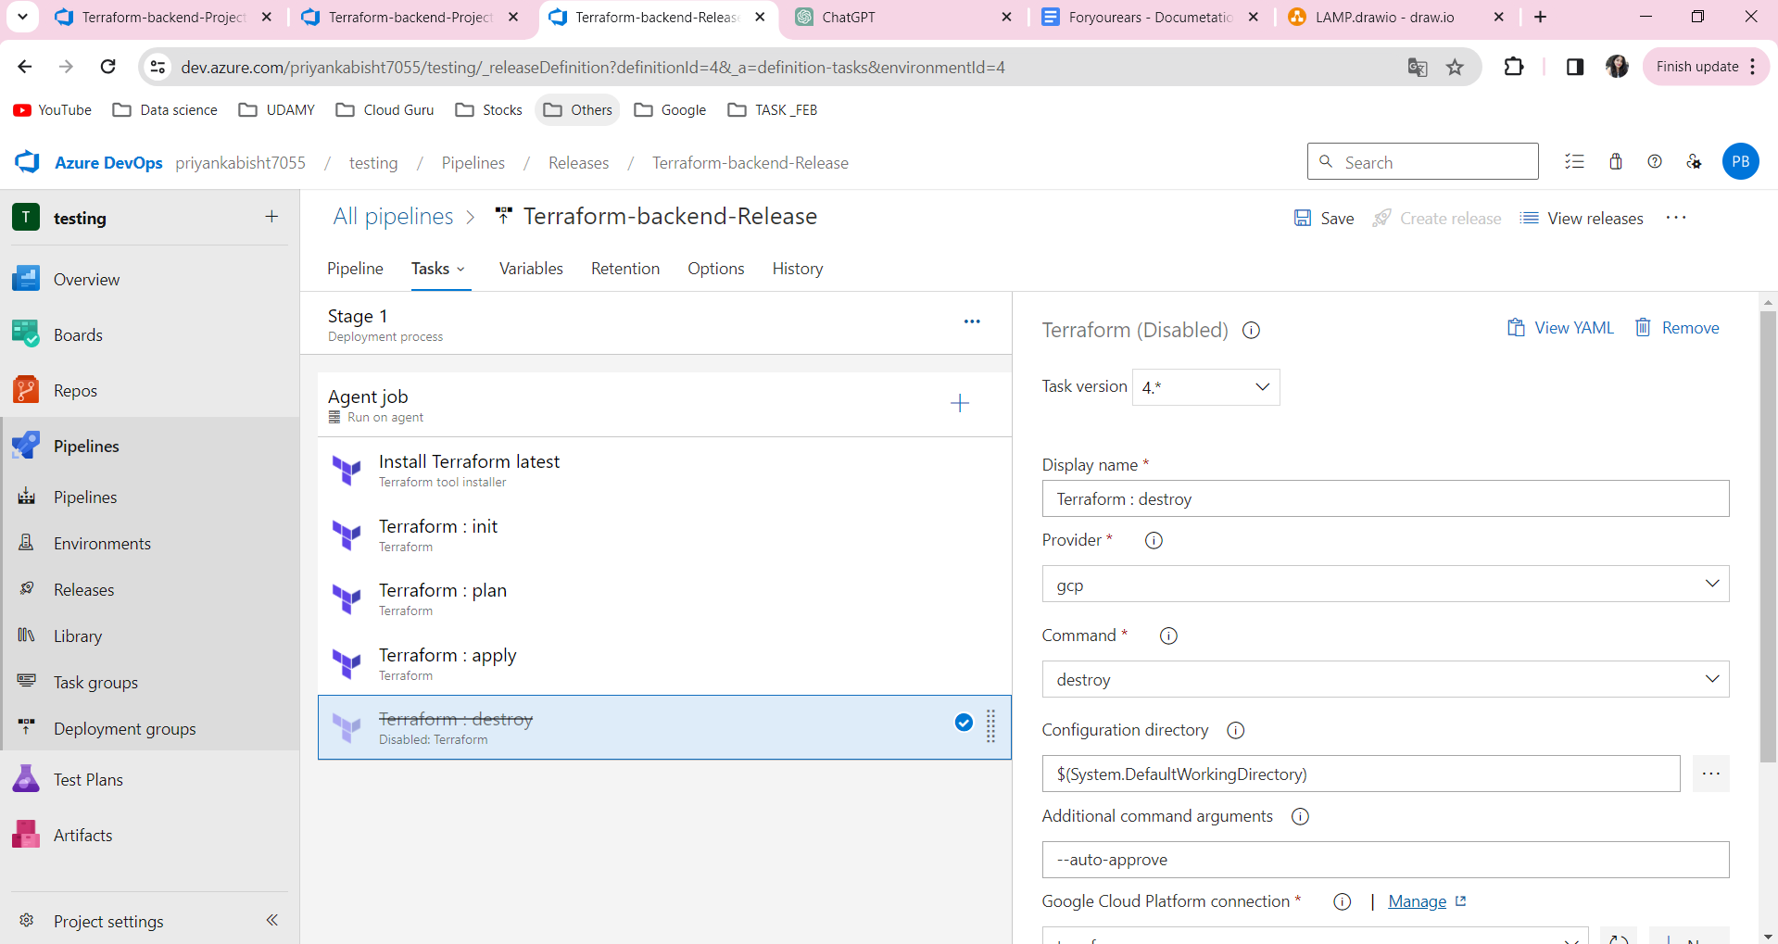

Now, configure Nginx as a reverse proxy in that code in which we were creating a golden image of the machine.
Nginx_reverse_proxy.conf.j2 -
https://github.com/Priyanka-Bisht/4yourearsProject-LAMP-Stack/blob/terraform/AppEngine-Project/nginx_reverse_proxy.conf.j2

Nginx.conf -
https://github.com/Priyanka-Bisht/4yourearsProject-LAMP-Stack/blob/terraform/AppEngine-Project/nginx.conf

Default.conf -
https://github.com/Priyanka-Bisht/4yourearsProject-LAMP-Stack/blob/terraform/AppEngine-Project/default.conf

Web.conf -
https://github.com/Priyanka-Bisht/4yourearsProject-LAMP-Stack/blob/terraform/AppEngine-Project/web.conf

Now, Check the GCP Console to cross check the infrastructure and hit the app engine URL, URL should hit the application which we have deployed.

Microservice-Deployment
Tools used in LAMP Stack Deployment:
Git
Azure Devops
Minikube
Crossplane
GCP
- Artifact Registry
- GKE
- ArgoCD
- Cloud Monitoring

Deployment-

Create service connection to connect azure devops to Docker .
Go to -> Project Setting - Service Connection - new service connection - Docker - fill the details
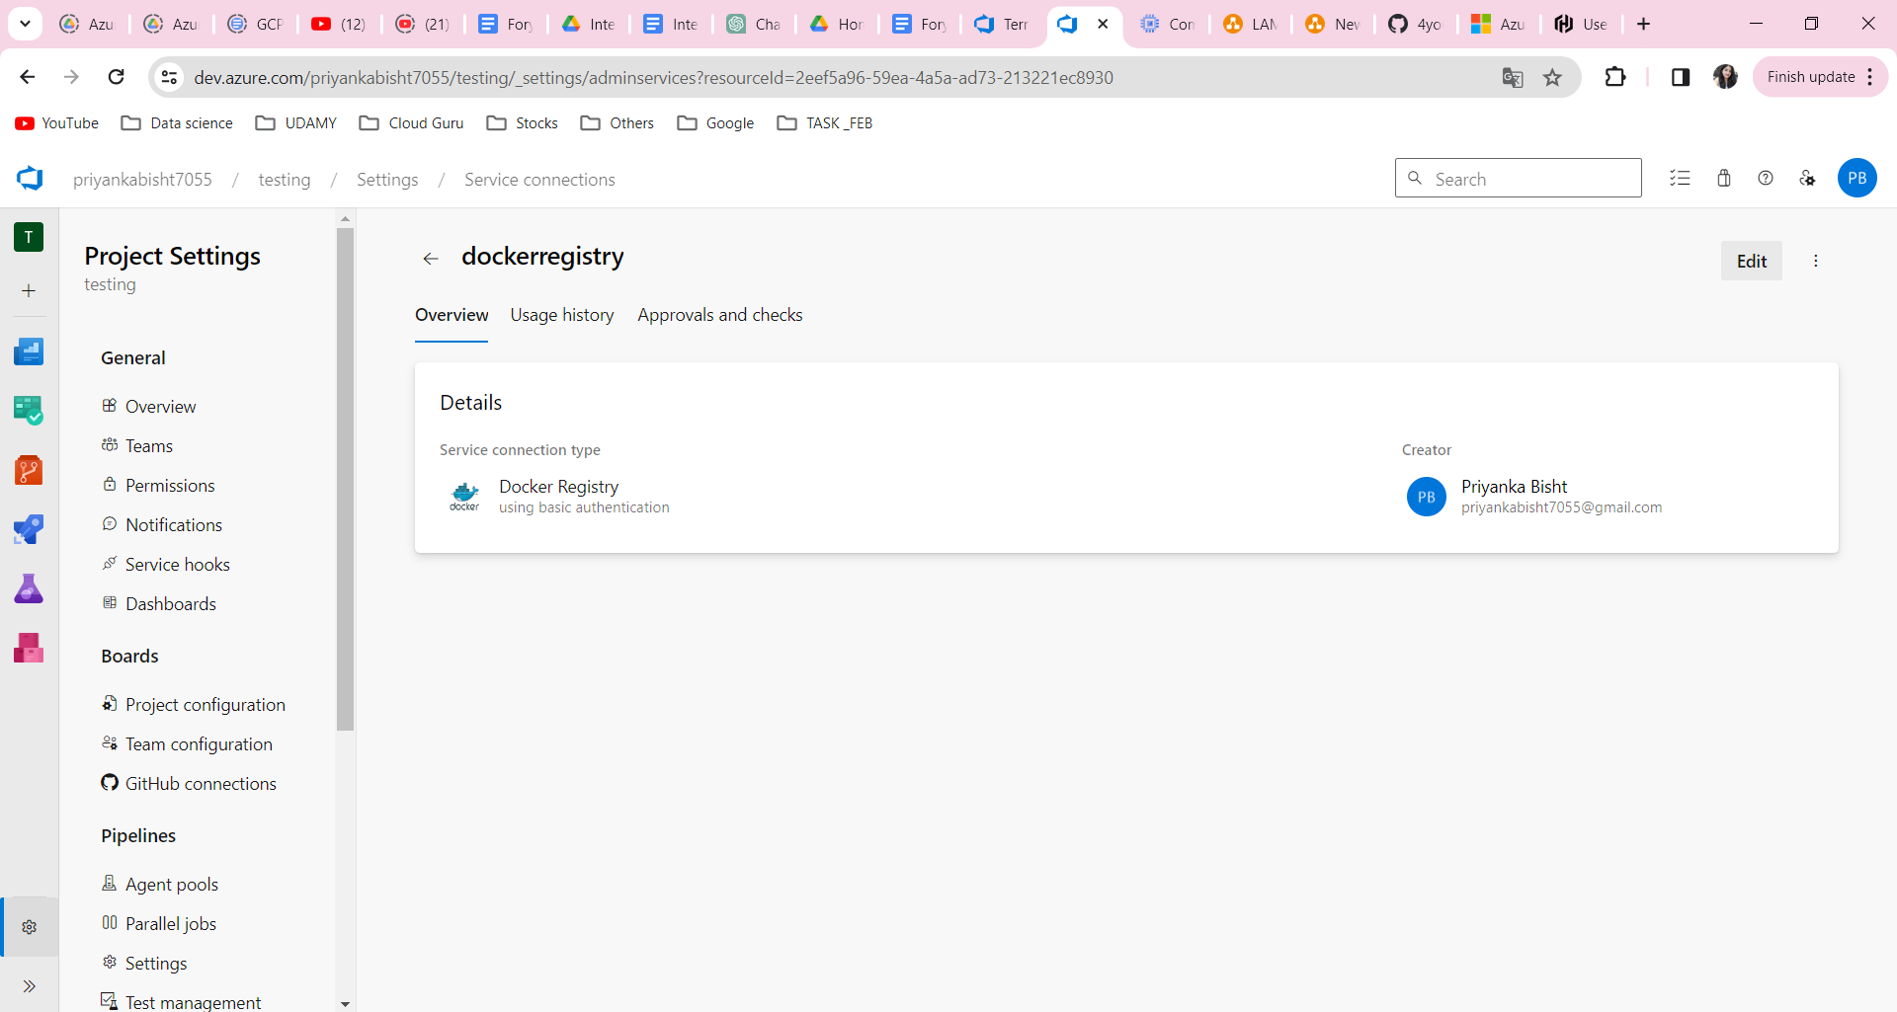

Create service connection to connect azure devops to Kubernetes .
Go to -> Project Setting - Service Connection - new service connection - Kubernetes - fill the details
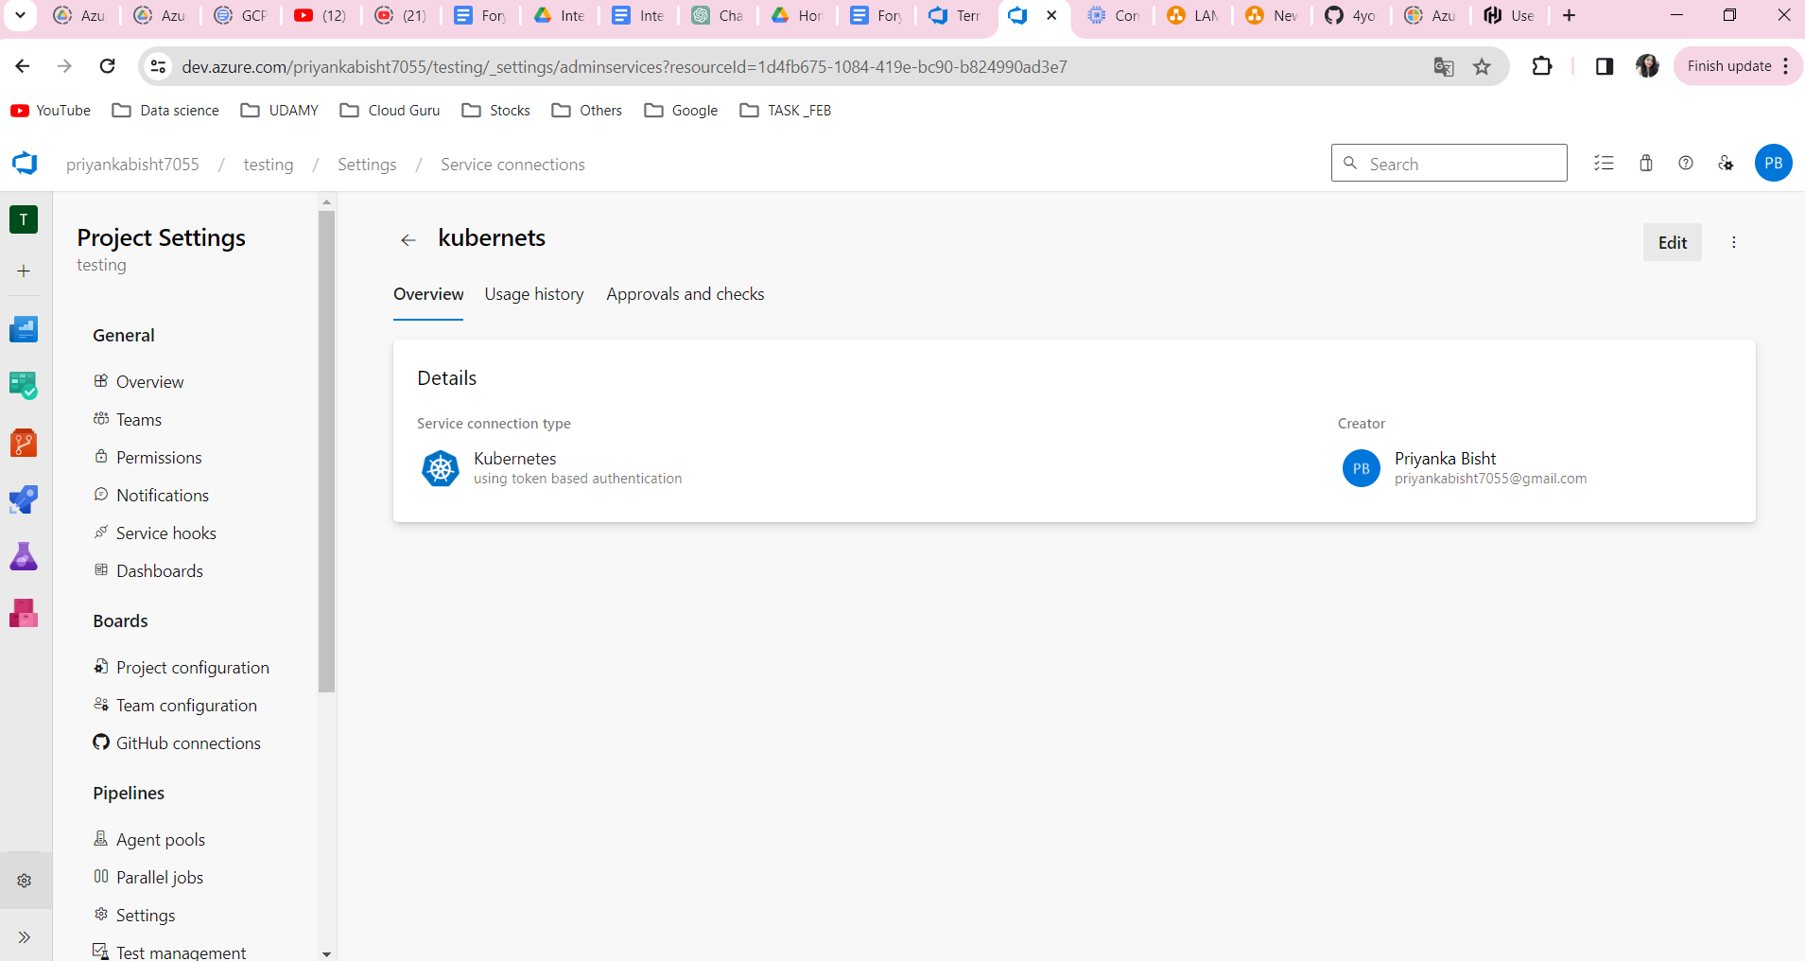

Write Deployment file which include deployment.yaml, service.yaml and HPA.yaml, argocd.yaml, dockerfile and azure-pipeline.yaml and using this build an image and deploy image in artifact registry.
Reference: https://dev.azure.com/priyankabisht7055/testing/_git/ArgoCD?path=/azure-pipelines.yml

To create infra in google cloud we will use crossplane, write yaml file to create network, subnetwork, cluster and finally node pool.
Reference: https://github.com/Priyanka-Bisht/Crossplane-4yourearsProject/tree/main/Crossplane/Cluster-deployment

After creating the cluster, we will configure argocd in the cluster and deploy applications on the cluster.
For outbound connection we are using load balancer ingress.
Reference: https://github.com/Priyanka-Bisht/Crossplane-4yourearsProject/blob/main/crossplane-configuration.txt
<<HIT THE APPLICATION URL>>

PROJECT SUMMARY

LAMP STACK DEPLOYMENT -
In my project I have worked on azure devops, Gcp cloud, packer, ansible, terraform .
Using terraform I have created an env for my app engine application. We have Created network, loadbalancer,manage instance group and appengine.
We used Ansible playbook for lamp stack, Using ansible playbook or packer we have created a vm golden image for deploying it in our instance group.
workflow of application like -
Whenever the user tries to access the application, At first the request will forward by load balancer to the backend instance group. In these instance group
We are using nginx reverse proxy. so this proxy will send traffic to the app engine node js application.

MICROSERVICE DEPLOYMENT -
I worked on a project where we used crossplane, azure devops, argo cd, and GKE.
Using a crossplane we have created a Gke cluster. For building and creating images we are using Azure devops.
For creating and deploying apps in gke we are using argoCd. ArgoCd will check the repo and deploy applications in gke. For outbound connection we are using load balancer ingress.

